**Manchester Metropolitan University**

Msc Computer Science 2023/24

Information Systems and Databases

**Project Plan – Group A14**

**Our Approach**

We approached the project by carryout each task individually after finishing the relevant lectures. The organizational tool of choice was Microsoft Teams, where distinct folders were created for each specific task. The completed work was uploaded to the designated folder *(Refer figure 1 below)*. When all the members finished a section, we scheduled an online meeting to compare and review the working of each member. Subsequently, we consolidated and finalised the respective section for our report.

*Figure 1 – Use of Microsoft Teams for the project*

Furthermore, assignment specification require User Case Specifications are to be done separately for each member. The individual contributions are as follows. However, it should be noted that all the individual UCS are also reviewed by the entire team.

1. Register Pet Owner & the Pet – by Sampath Karunarathne
2. Register A New Pet Under an Existing Pet Owner – by Arsema
3. Make Appointments – by Daniela O Achelus
4. Cancel Appointments – by Tha Lin Htet
5. Update Pet Medical Records – by Akhil Varma

Finally, the executive summary was done after the conclusion of all the other tasks. We approached this summary as a collaborative effort undertaken by all the team members rather than carrying out individually.

Additionally, for the effective task allocation and progress tracking of the assignment, we created a project plan / tracker (*Refer figure 2 below*) in Microsoft Teams. After a team member completes a task and uploads the corresponding work to the designated folder, they mark the task as 'YES' in the project plan. This helped us to monitor tasks that are yet to be completed, those that have been finalized and the overall progress of the assignment.

We believe our approach allows our team members to focus on clearly defined responsibilities, promoting a more in-depth understanding of each task rather than one depending on other team members to carry out the assignment tasks.

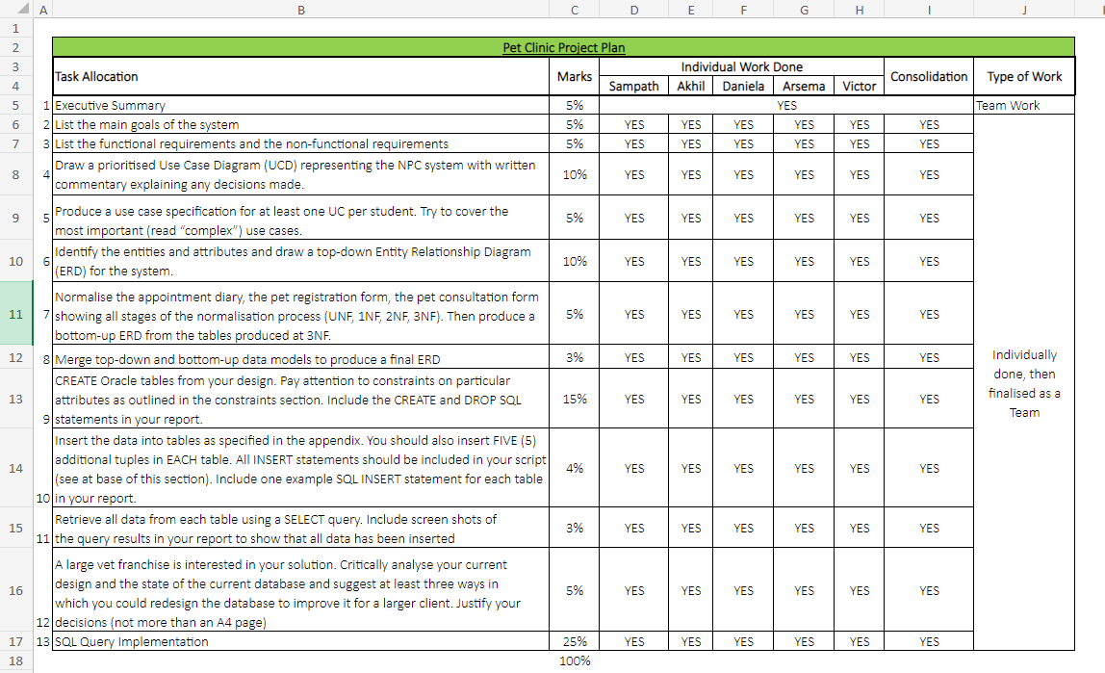

*Figure 2 – Our Project Plan/Tracker*